CPIA 1 FOGGIA
A.S.2019/20
PRIMO PERIODO DIDATTICO-LINGUA INGLESE
UDA N°1
Presentarsi
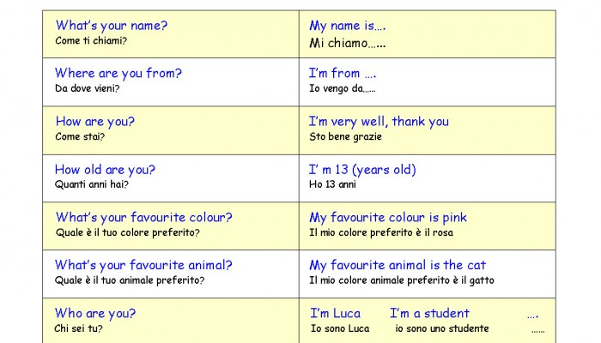

Esercizio :
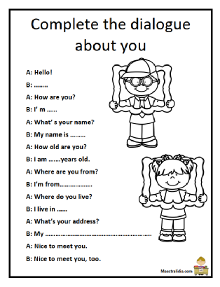
Salutarsi
Ciao(hello, bye-bye); Buongiorno(good morning); Buon Pomeriggio(Good Afternoon); Buonasera(good evening); Buona notte(good night); Arrivederci(good-bye)
Piacere di conoscerti: Nice to meet you.

The english alphabet
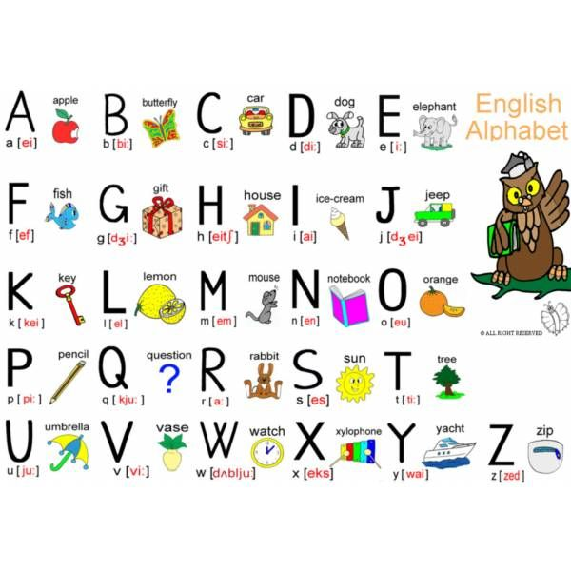SPELLING: nominare le lettere che formano una parola.
ES. HOUSE: EICH-OU-IU-ES-I
PRONOMI PERSONALI SOGGETTO: IO(I)-TU(YOU)-LUI(HE)-LEI(SHE)-ESSO(IT)-NOI(WE)-VOI(YOU)-ESSI(THEY).
Esercizio: sostituisci i nomi tra parentesi con i pronomi personali soggetto adeguati.
- (The school) ___________ is open
- (Arnold and Ted) ____________ are good football players.
- (Bob and I) ___________ are italian.
- (My car) __________ new.

PRESENTE DEL VERBO ESSERE TO BE: PRESENT SIMPLE
S. Present: affermativa
Soggetto | TO BE | Contratta
I | am | I'm
you | are | you're
he | is | he's
she | is | she's
it | is | it's
we | are | we're
you | are | you're
they | are | they're
S. Present: negativa
Sogg | TO BE | NOT | Contratta
I | am | not | I'm not
you | are | not | you aren't
he | is | not | he isn't
she | is | not | she isn't
it | is | not | it isn't
we | are | not | we aren't
you | are | not | you aren't
they | are | not | they aren't
S. Present: interrogativa
TO BE | Soggetto
am | I ?
are | you ?
is | he ?
is | she ?
is | it ?
are | we ?
are | you ?
are | they ?
S. Present: interrogativa-negativa
TO BE | Sogg | NOT | Contratta
am | I | not | aren't I
are | you | not | aren't you
is | he | not | isn't he
is | she | not | isn't she
is | it | not | isn't it
are | we | not | aren't we
are | you | not | aren't you
are | they | not | aren't they
Completa le seguenti frasi con la forma corretta del verbo to be.
Usa le forme non contratte:
- My name … Bond
- We …. the champions
- Chantal and her mother …. from France
- I … fine, and you?
- It …. 1.30 p.m.
- You …. my best friend
- Tom …. a very good tennis player
- Our parents …. at home now
- Sheila …. a journalist
- I … 20 years old

